KING FAHD UNIVERSITY OF PETROLEUM & MINERALS COMPUTER ENGINEERING DEPARTMENT
COE 344: Computer Networks
Term 251 (Fall 2025-2026)
Optional Project

By
Hussein

OSPF NEIGHBORS:
RTR1: 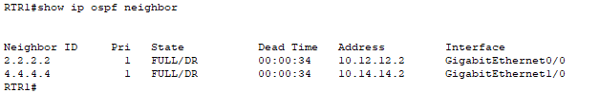
RTR2:
RTR3:
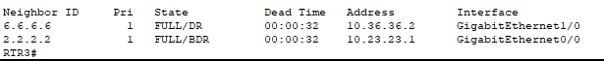
RTR4:
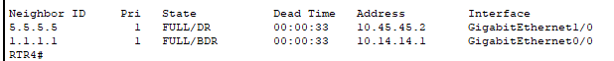
RTR5:
RTR6:

ROUTING TABLES:
RTR1:
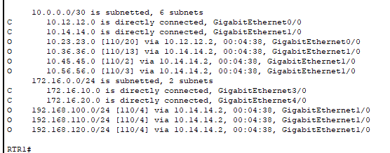
RTR2:
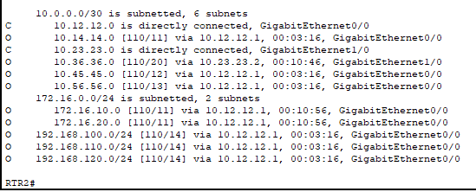
RTR3:
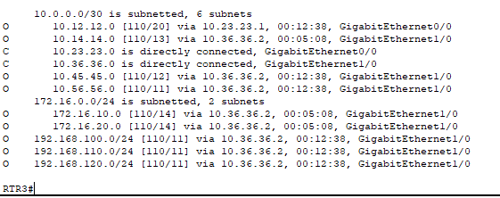
RTR4:
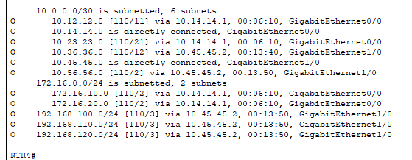
RTR5:
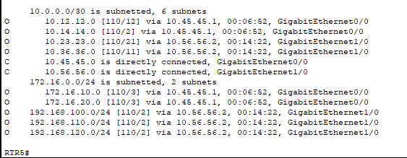
RTR6:
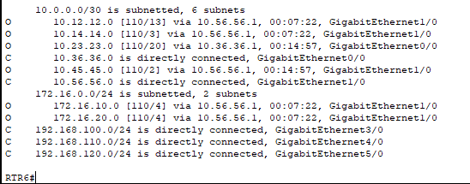

DHCP Configuration Commands on RTR1:
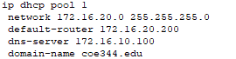
Hosts IP Configuration and DNS resolution:
Host1:
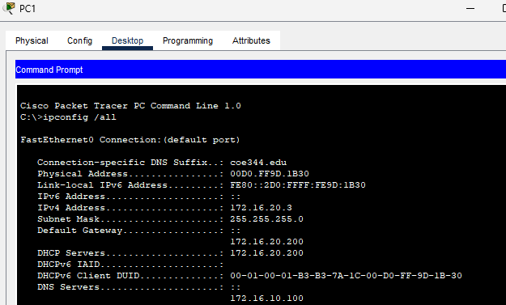
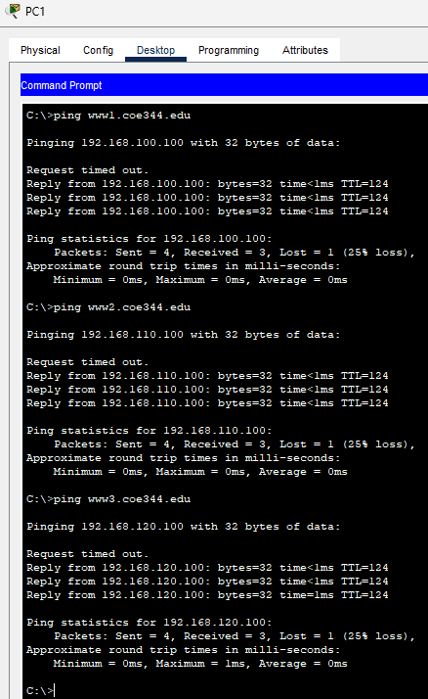
Host2:
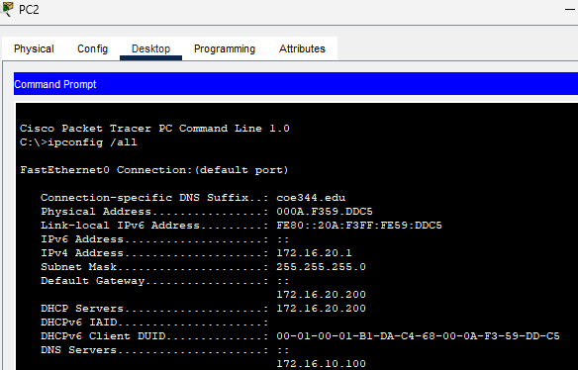
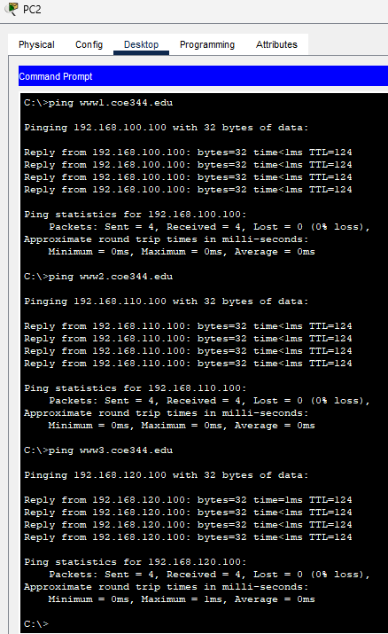
Host3:
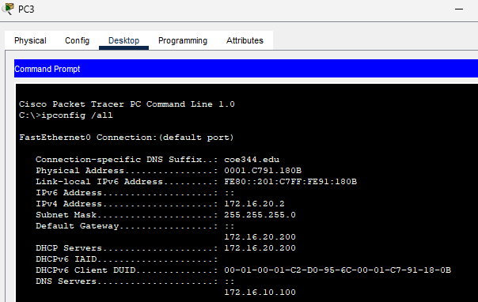
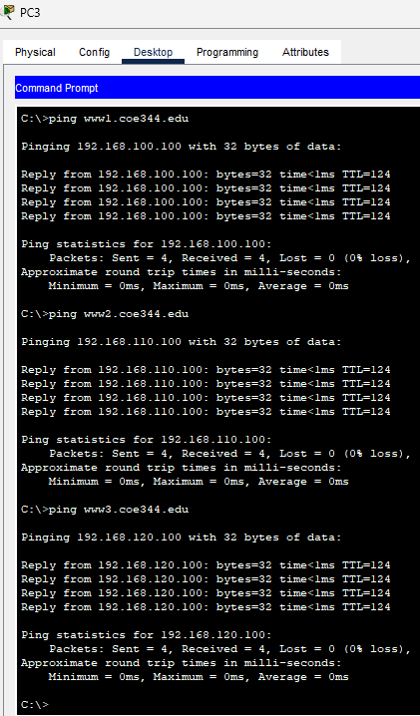
Reachability between hosts and between hosts and webservers:
Host1:
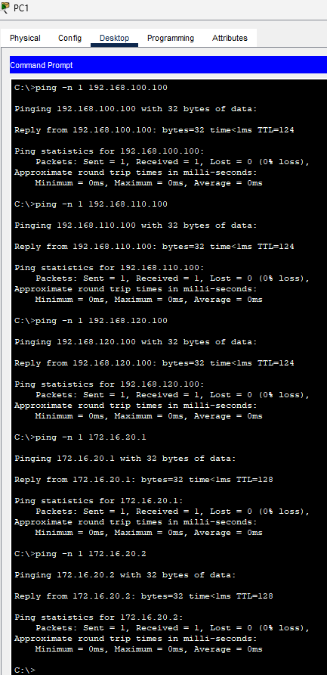
Host2:
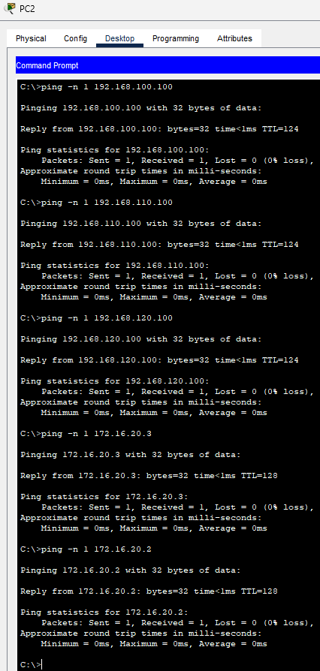
Host3:
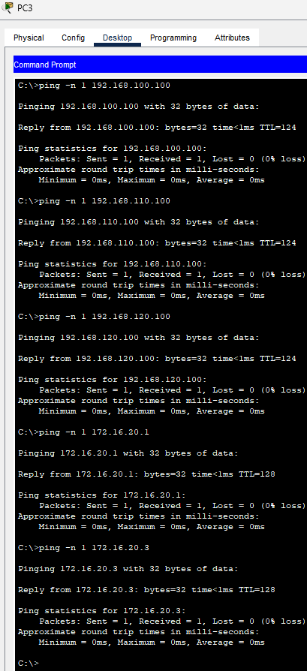
Path reachability between hosts and webservers using traceroute:
Host1:
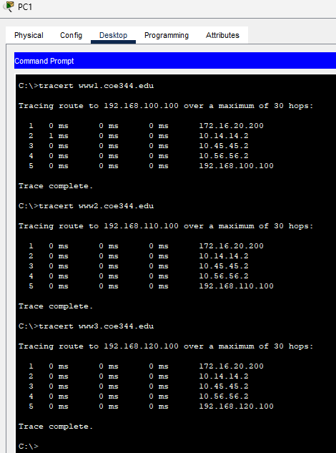
Host2:
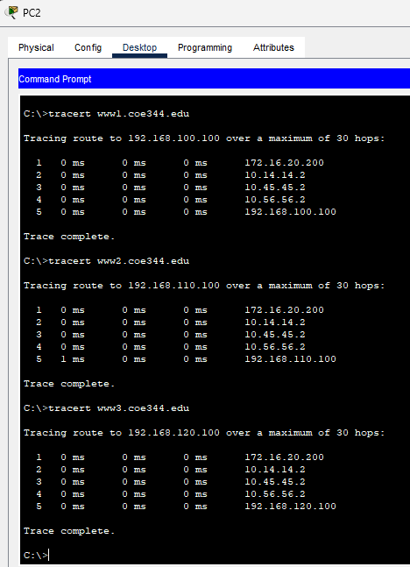
Host3:
